**Part 1: Shell Basics**

**Step 1: Access the Command Line**

**Step 2: Display Manual Pages from the command line**

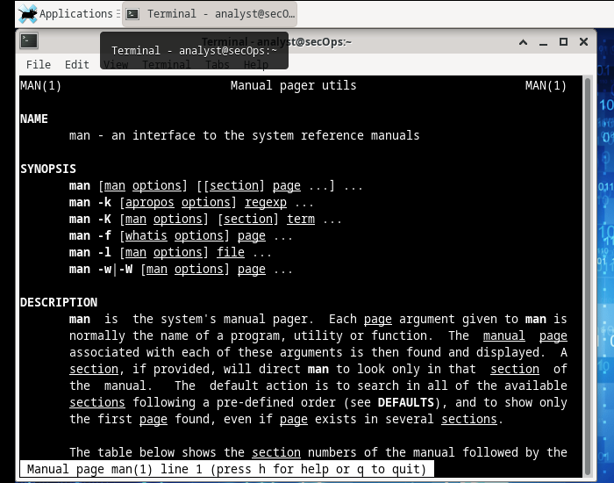

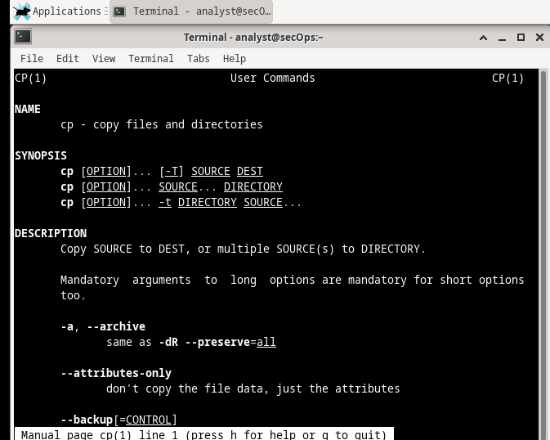

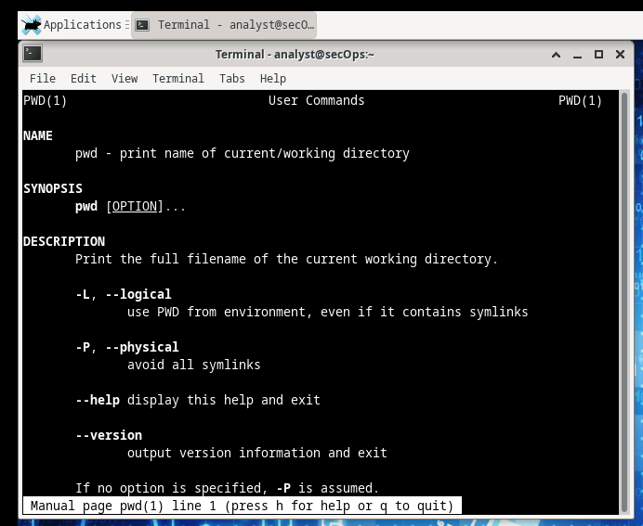

**Step 3: Create and change directories.**

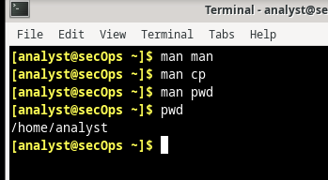

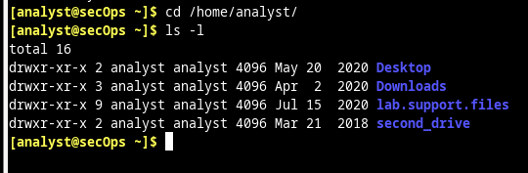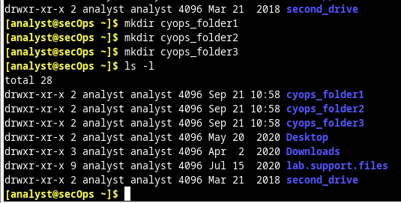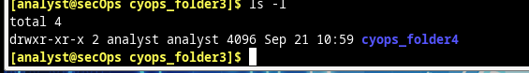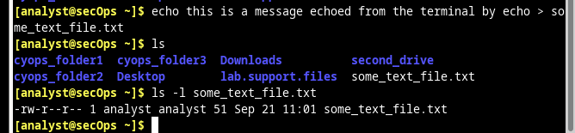

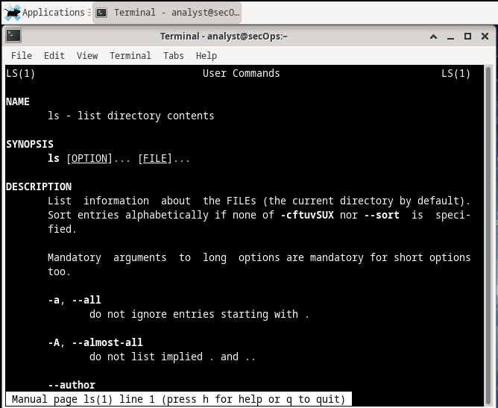

**Part 2: Copying, Deleting, and Moving Files**

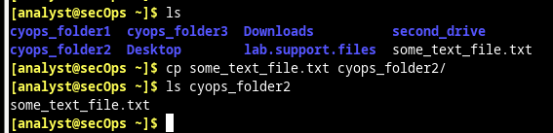

**Step 2: Deleting Files and Directories**

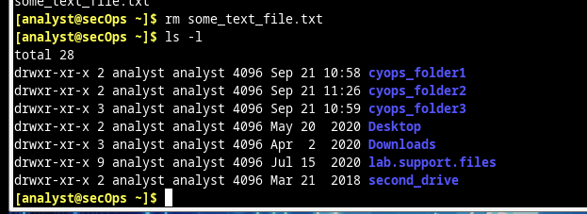

**Step 3: Moving Files and Directories**

